**DBBC3 Testing for APEX and Pico Veleta Continued**

Alan Roy, Sven Dornbusch, Jan Wagner, Gino Tuccari, Helge Rottmann

21.12.2018

**Objective**

This document describes further testing results since the 2018sep13 Engineering Review and the 2018nov06 Nijmegen EHT Collaboration Meeting to resolve ORA’s and Nijmegen suggestions. It provides space for more complete answers where needed than is available in the ORA Register.

**Summary**

Scatter has been much reduced on measurements of efficiency by using improved analogue combiner network using couplers, using DiFX+fourfit instead of zerocorr, include matching pads between last amplifier and r2dbe or DBBC3 input, correcting an erroneous cell reference in the spreadsheet calculation of the analogue correlation coefficient, and the use of Vivado-compiled firmware in the DBBC3 might have lead to better timing.

Improve efficiency: the best efficiency measurement DBBC3 IFA-IFC OCT2-4 has correlation coefficient 96.8 % of the ideal value over a range of ρanalogue values.

The efficiency was found to depend strongly on the part of the band we include in the average, due to the noise source bandshape and quantization noise.

A numerical simulation of bandshape and quantization noise shows how autocorrelation bandshapes are distorted by the spreading of quantization noise from the peak of the band.

We obtained good agreement between the bandshape measured with spectrum analyzer and the autocorrelation spectra measured with the DBBC3, by setting the spectrum analyzer to be on linear vertical scale, squaring the voltage values to get linear power scale, and examining the input to the sampler card rather than input to the GCoMo.

**ORA Register from the Engineering Review 2018sep13:**

https://docs.google.com/spreadsheets/d/1bnaFspulG-kriKj71lpIOk-mRn9KkzSUhMTAMw8N4gU/edit?usp=sharing_eip&ts=5b886ec6

https://www.dropbox.com/home/DBBC3Review

**Comments/suggestions from the Nijmegen meeting 2018nov06:**

**Summary by J Weintroub email 2018nov07:**

0. Improved analog test setup with couplers, and improved test results including R2DBE lab measurements with same setup are acknowledged. Things are improved, not quite at the level of figure 7 in the R2DBE paper Vertatschitsch et al.

1. There is a large discrepancy between the noise spectrum used for testing as measured in the analog domain, and the noise spectrum reconstructed as a digital auto-correlation.  Digital shape  should match analog, needs to be resolved.

2. The zero-baseline test done at APEX on or around 20 October looks promising. Work to finalize 5 km baseline correlations between DBBC3 APEX recording and ALMA and R2DBE APEX recording and ALMA, these could yield the performance result needed (or conversely not) independent of the lab tests.

3. Fix intermittent known PPS timing bug in DBBC3, causing some of the zero baseline correlations from 2. to be full of nasty artifacts.

4. Generally evaluate the impact of noise passband shape and passband slope

5. repeat measurements on DBBC3 single channel to single channel multiple times to validate whether there is random scatter contributing to error bars.

6. Compare 0-2 GHz and 2-4 GHz DBBC3 bands, and the different channels of the DBBC3.

7.  quad core calibration, reference.  Acknowledged based on lack of spurs that quad core calibration is adequately executed.

<https://www.worldscientific.com/doi/pdf/10.1142/S2251171714500019>

8. R2DBE measurement: include matching pads between last amplifier and R2DBE

9. Use identical analogue configuration (0-2 GHz LPF in main branch, additional amplifier stage, attenuate for DBBC3) for R2DBE and DBBC3.

10. Measure more points in the range rho_analog 0-0.3, zoom in the plot as in the Vertatschitsch et al. 2015 PASP paper.

**ORA #1 (AY):**

***No atmospheric variation in PPS***

**Cause**

A watchdog in firmware monitors the internal PPS against the external PPS and in the event that the difference is too large triggers a resynchronization on the external PPS. However the internal PPS was being generated from the wrong clock domain at 128 MHz instead of 256 MHz so was running at half the rate and the watchdog saw a large timing error each second. It triggered a resync each second, causing the internal PPS to follow the external PPS (and so follows GPS), plus in borderline cases the synchronization would fall on one side or other of the clock edge of the FPGA 256 MHz clock, causing a clock jump of 4 ns as in the following fringe plot.

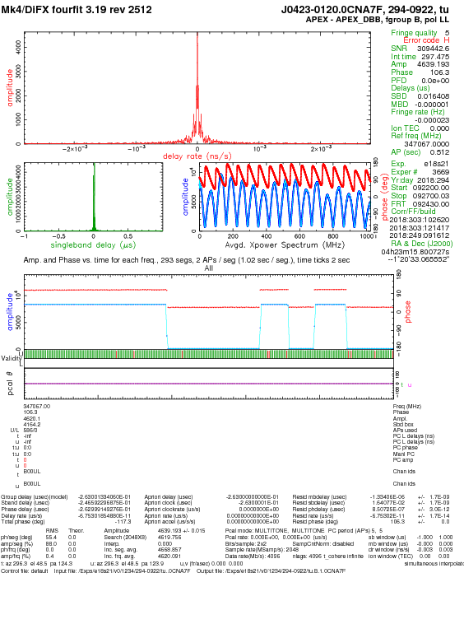

**Figure**: Fourfit plot from 2018oct21 EHT 345 GHz test illustrating the PPS bug effect on the zero baseline DBBC3-R2DBE at APEX. Amplitude dropped to zero occasionally when the DBBC3 clock jumped 4 ns due to the DBBC3 resyncing on the 1 PPS and occasionally being off by one clock cycle at 256 MHz depending on which side of the clock edge the PPS arrived.

**Fix**

A two-line change in firmware derives the internal 1 PPS derived from the 256 MHz clock and the threshold for out-of-sync detection in firmware was raised to some tens to 100 μs. To achieve stable compilation, the firmware was ported to Vivado and then compiled successfully.

**Verification 1:**

Stability test of Internal 1 PPS: After sync on lab 1 PPS, the *1 PPS in* was disconnected and we compare *1 PPS Mon* vs lab 1 PPS over many days on a digital storage oscilloscope. No slips of internal 1 PPS were seen, firmware stable.

**Verification 2:**

Repeat the zero-baseline test in the lab between R2DBE and DBBC3 and make a long recording and fringe-fit to verify stable amplitude.

**Hardware Setup:**

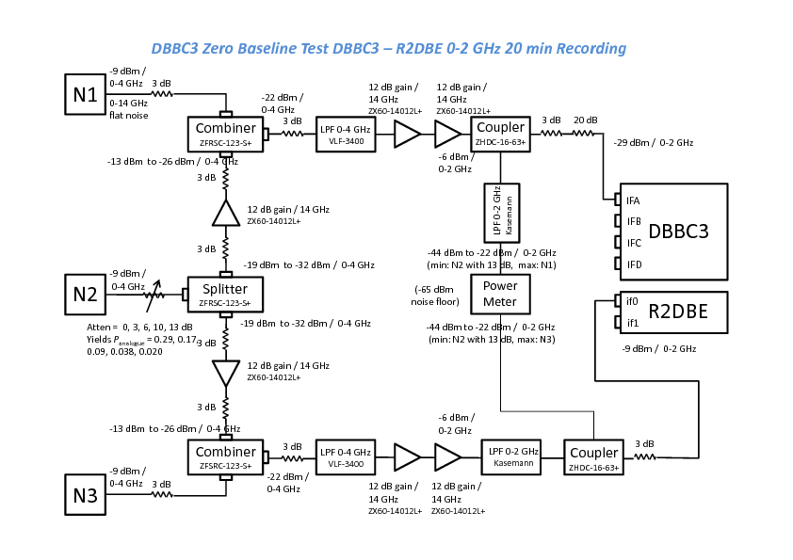

**Figure**: Analogue signal preparation for the PPS bug fix verification. N1 and N3 were off for the test.

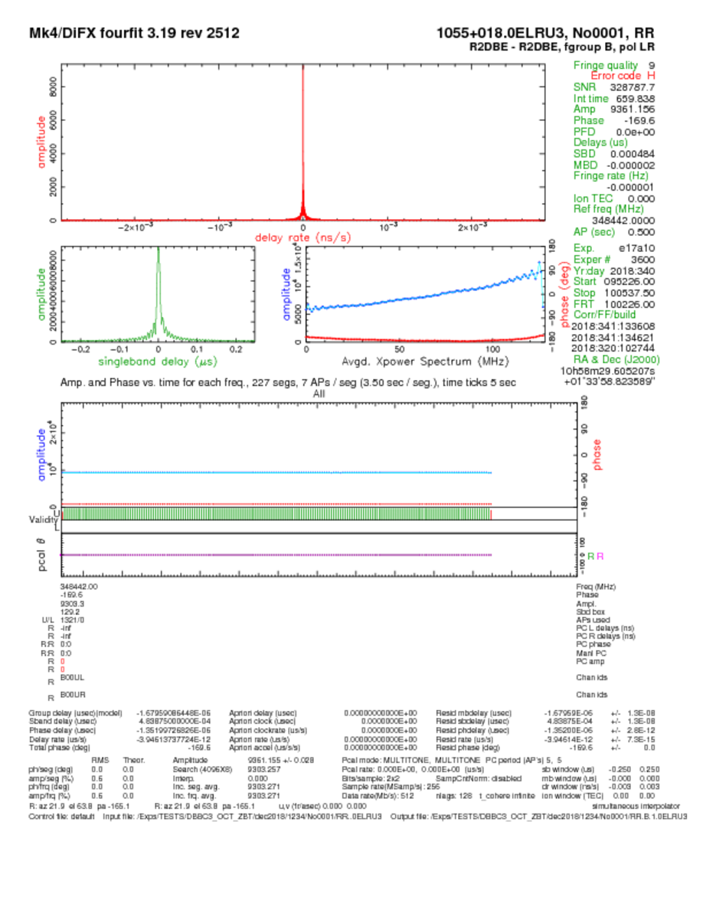

**Figure**: Fringe plot after PPS bug fix. Amplitude is stable for 11 min on the zero baseline R2DBE - DBBC3 in the lab, verifies the bug fix. Amplitude is 93.6 % for 100 % correlated noise, shows good efficiency. The two streams were treated as two polarizations of a single station so the amplitude full-scale is 10000 whitneys. Zoom band selected 128 MHz of bandwidth near the peak of the noise source output, to minimize effects of noise source bandshape.

**ORA #5 (AY):**

***Cross-compare R2DBE and DBBC3 on-sky data recorded in parallel***

**Parallel Recordings:**

**2017EHT**

DBBC3 and R2DBEs were operated in parallel sampling the same IF. One scan was correlated, not more due to pressure from production correlation of EHT2017. Modules had to be released for EHT2018. Fringes were found. Spectrum showed severe band slope that has now been corrected in the selection of GCoMo amplifiers, and firmware changes have been made between then and now. The October 2018 EHT 345 GHz fringe test data are more useful.

**October 2018 EHT 345 GHz Fringe Test**

Parallel recordings with DBBC3 and R2DBE were made with the following setup at APEX.

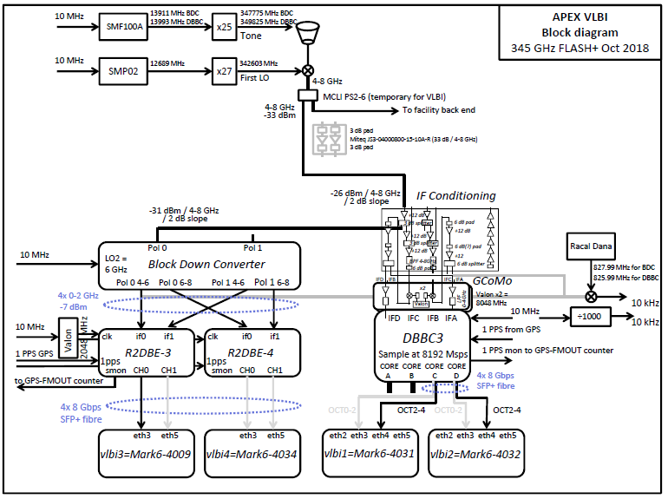

**PPS Bug in Firmware:** The PPS bug was present during the run. It had actually been fixed prior to the run but compilation was not stable, so we observed with the bug still present. The following fringe plots show selected scans and times when the DBBC3 clock was correct and so useful for cross comparison.

**Schedules**

e18p17 and e18s17: ALMA had poor phasing due to weather

e18p19: Good replacement run:

Day 291 is Thu 18 Oct 2018 MJD 58409

SCAN DAY START UT SOURCE TYPE STATIONS t => tape change

STOP UT Aa Ax Gl Pv Na

1 291 23:44:00 CTA102 - 49 49 24 45 36

291 23:49:00 1mmlcp.set - 0 0 0 0 0

2 291 23:52:00 CTA102 - 50 50 24 44 34

gap 291 23:57:00 - - 170 170 170 170 178

3 292 00:07:00 3C454.3 - 45 45 29 48 39

292 00:12:00 - - 588 584 587 576 584

4 292 00:15:00 3C454.3 - 46 46 29 46 37

gap 292 00:20:00 - - 170 170 170 170 178

5 292 00:30:00 BLLAC - 25 25 56 44 41

292 00:35:00 - - 582 568 577 508 526

6 292 00:38:00 BLLAC - 25 25 56 43 40

freq 292 00:43:00 - - 170 170 170 170 178

7 292 01:03:00 BLLAC - 24 --- --- 38 ---

292 01:07:00 - - 1130 --- --- 1190 ---

8 292 01:09:00 BLLAC - 24 --- --- 37 ---

292 01:13:00 - - 110 --- --- 110 ---

9 292 01:13:30 BLLAC - 24 --- --- 36 ---

292 01:23:30 - - 20 --- --- 20 ---

e18s21: Good replacement run:

Day 294 is Sun 21 Oct 2018 MJD 58412

SCAN DAY START UT SOURCE TYPE STATIONS t => tape change

STOP UT Aa Ax Sw Gl

1 294 09:22:00 J0423-0120 - 48 48 36 10

294 09:27:00 1mmlcp.set - 0 0 0 0

2 294 09:30:00 J0423-0120 - 47 47 37 9

294 09:35:00 - - 170 170 170 170

3 294 09:38:00 J0423-0120 - 45 45 39 9

gap 294 09:43:00 - - 170 170 170 170

4 294 09:53:00 J0510+1800 - 38 38 38 29

294 09:58:00 - - 585 560 507 580

5 294 10:01:00 J0510+1800 - 37 37 40 29

294 10:06:00 - - 170 170 170 170

6 294 10:06:30 J0521+1638 - 39 39 38 28

294 10:11:30 - - 19 17 19 18

7 294 10:17:00 J0510+1800 - 34 34 44 28

294 10:22:00 - - 319 317 319 318

8 294 10:22:30 J0510+1800 - 33 33 45 28

gap 294 10:27:30 - - 20 20 20 20

9 294 10:37:00 J0522-3627 - 53 53 18 ---

294 10:42:00 - - 547 487 545 ---

10 294 10:45:00 J0522-3627 - 51 51 19 ---

294 10:50:00 - - 170 170 170 ---

**Scan 292-0003 first 90 s Zero-Baseline APEX DBBC3 – R2DBE**

|  |  |
| --- | --- |
|  | **adhoc phases applied** |
|  | **bandpass phases uncorrected** |

**Scan 292-0003 first 90 s ALMA – APEX**

|  |  |
| --- | --- |
|  | **DBBC3** |
|  | **R2DBE** |

**Scan 292-0003 first 90 s ALMA – APEX with adhoc phases applied**

|  |  |
| --- | --- |
|  | **DBBC3** |
|  | **R2DBE** |

**Scan 292-0003 last 90 s Zero Baseline APEX DBBC3 – R2DBE**

|  |  |
| --- | --- |
|  | **adhoc phases applied** |
|  | **Bandpass phases uncorrected** |

**Scan 292-0003 last 90 s ALMA – APEX**

|  |  |
| --- | --- |
|  | **DBBC3** |
|  | **R2DBE** |

**Scan 292-0003 last 90 s ALMA – APEX with adhoc phases applied**

|  |  |
| --- | --- |
|  | **DBBC3** |
|  | **R2DBE** |

**Scan 294-0006 / 300 s / APEX DBBC3-R2DBE zero baseline correlated full-band**

|  |  |
| --- | --- |
|  | **DBBC3 – R2DBE zero baseline** |

**Result Summary**

**Zero Baseline DBBC3 – R2DBE**

|  |  |  |
| --- | --- | --- |
| ***Scan*** | ***Parameter*** | ***DBBC3 - R2DBE*** |
| Scan 292-0003 first 90 s | Amp | 7312 whitney |
| Scan 292-0003 first 90 s adhoc phases applied | Amp | 8407 whitney |
| Scan 292-0003 last 90 s | Amp | 7237 whitney |
| Scan 292-0003 last 90 s adhoc phases applied | Amp | 8316 whitney |
| Scan 294-0006 all 300 s, full-band 0-2 GHz | Amp | 9094 whitney |

**Note:** Correlated as a baseline between two stations; amp scale is 11300 whitney = 100 % correlated.

**Baseline APEX – ALMA:**

**Scan 292-0003 first 90 s ALMA - APEX**

|  |  |  |  |
| --- | --- | --- | --- |
| ***Parameter*** | ***R2DBE*** | ***DBBC3*** | ***Difference*** |
| SNR | 15.5 | 16.4 | +5.8 % |
| Amp | 0.314 whitney | 0.332 whitney | +5.7 % |
| SB delay | -0.006318 μs | -0.010414 μs | -4.1 ns |
| MB delay | 0.000270 μs | -0.003012 μs | -3.3 ns |
| Fringe rate | 0.004652 Hz | 0.004570 Hz | 0.08 mHz |

**Scan 292-0003 first 90 s ALMA – APEX adhoc phases applied**

|  |  |  |  |
| --- | --- | --- | --- |
| ***Parameter*** | ***R2DBE*** | ***DBBC3*** | ***Difference*** |
| SNR | 24.8 | 23.1 | -6.9 % |
| Amp | 0.503 whitney | 0.467 whitney | -7.2 % |
| SB delay | 0.000001 μs | 0.000001 μs | 0 μs |
| MB delay | 0.000001 μs | 0.000001 μs | 0 μs |
| Fringe rate | 0.005352 Hz | 0.005177 Hz | 0.18 mHz |

**Scan 292-0003 last 90 s ALMA - APEX**

|  |  |  |  |
| --- | --- | --- | --- |
| ***Parameter*** | ***R2DBE*** | ***DBBC3*** | ***Difference*** |
| SNR | 13.2 | 12.3 | -6.8 % |
| Amp | 0.268 whitney | 0.248 whitney | -7.5 % |
| SB delay | -0.006527 μs | 0.005551 μs | +12.1 ns |
| MB delay | 0.000245 μs | -0.004464 μs | -4.7 ns |
| Fringe rate | 0.009274 Hz | 0.008826 Hz | -0.45 mHz |

**Scan 292-0003 last 90 s ALMA – APEX adhoc phases applied**

|  |  |  |  |
| --- | --- | --- | --- |
| ***Parameter*** | ***R2DBE*** | ***DBBC3*** | ***Difference*** |
| SNR | 18.3 | 15.7 | -14.2 % |
| Amp | 0.371 whitney | 0.317 whitney | -14.6 % |
| SB delay | 0.000864 μs | 0.016167 μs | 15.3 ns |
| MB delay | 0.000010 μs | -0.01425 μs | -14.3 ns |
| Fringe rate | 0.008750 Hz | 0.008826 Hz | 0.08 mHz |

**Discussion**

Fringes were detected on the APEX – ALMA baseline with both backends but fringes were surprisingly weak; SNR should be in the thousands like at 230 GHz. The cause is not known but there was known poor coherence at APEX visible from the coherence test. In any case the low SNR is not due to the backends as both backends give similar results.

*Zero-baseline APEX DBBC3 to R2DBE:*

Efficiency for scan 292-0003 before ad hoc phases was 64.4 % and with ad hoc phases applied was 74.0 %.

The best efficiency measured was for scan 294-0006 all 300 s, full-band 0-2 GHz, for which the efficiency was 80.5 % (amp = 9094 whitney and normalized by 11300 whitney).

*“Long”-Baseline fringe to ALMA:*

Two comparisons were made of the SNR measurements from the two backends, and in each case the backends agree within 7 %. In one case the DBBC3 SNR was 5.8 % higher than that from the R2DBE, in the other case the DBBC3 SNR was 6.9 % lower than the R2DBE. Given that the SNR on each measurement was 15.5 and 13.2, the noise fluctuations are 6.5 % and 7.6 % and so the differences are less than 1 σ. However, this < 1 σ statement assumes the noise is independent between the DBBC3 and R2DBE determinations, which is questionable here since the noise is common, being dominated by the system upstream of the two backends. In any case a more precise comparison would have required a stronger fringe detection.

**ORA #8 (JW) and ORA #33 (SD):**

***Expand on Objectives and Requirements***

Objectives were stated on p1 of the 2018sep13 engineering review submission as: “Ensure the DBBC3 is operating correctly for use with EHT at APEX and Pico Veleta.”, to which JW commented in this ORA “… exceedingly terse and the very epitome of top level” and gave some suggestions for unpacking this into something more useful as a reference against which to judge the performance of the DBBC3. Here we attempt a set of requirements.

Background by G. Tuccari: The DBBC3 was an extension of the DBBC2 and DBBC1 which were the replacement of the MKIV terminal. The goal was to reproduce in digital format the system that was no longer available and obsolete, with possible improvements that a digital environment would enable. The DBBC2 was approved by a panel established by the EVN. The DBBC3 was required to be compliant with the previous DBBC systems but with bandwidth of 4 GHz per IF. Thus the specification tables start with the MKIV Haystack specification, which should be equalled or improved upon with bandwidth, data rate, sensitivity, flexibility.

The VLBA Project Book contains detailed specifications by Alan Rogers on the analogue rack and digitization, similar to the MKIV, and the document is readily on hand. The scanned chapters are in Appendix B in this document.

The fundamental driver for the specs is summarized on p7-2 of the VLBA Project Book as “The above should ensure the closure errors are < 0.1 degrees”, and this is also a good aim for the EHT system requirements given the importance of closure-phase analysis. To translate this into bandpass shape specifications needs us to consider the EHT analysis path and whether complex bandpass calibration is applied and with what frequency resolution. This is more involved than the time available before this review allows.

**ORA #13 (LB) and ORA #35 (SD):**

***Bandpass Ripple***

The strong bandpass ripple came from mismatch in the power splitter after the common noise source. Changing out for broad-band better matched resistive splitters/combiners made the following improvement.

|  |  |
| --- | --- |
|  |  |

**Figure:** 0-2 GHz normalized bandpasses with zerocorr and Left: Sep 2018, Right: 2018nov05 with improved analogue combiner network.

***Bandpass Shape***

We are out of time to address this properly for the 2018dec14 review decision deadline. To show the OCT filter shapes requires separating the overall autocorrelation bandpasses into the various contributing components:

1. Noise source bandshape,
2. Analogue conditioning bandpass shape,
3. Sampler frequency response,
4. Quantization noise spreading from the noise source bandshape,
5. OCT filter bandpass.

Most of these spectra have been acquired and shown on the next page. Item 3 requires swept tone and counting digital response amplitude, which we are out of time to do. The decomposition of the various spectra to remove their effect from the autocorrelation spectrum has not been done in time for the report and so we cannot show the OCT filter shape. The theoretical shape calculated from the tap weights is shown on p25 of the 2018sep12 report.

|  |  |
| --- | --- |
| 1. ***Noise Source at GCoMo input***   Horizontal: 0-5000 MHz  Vertical: 10 dB/div |  |
| 1. ***Analogue Conditioning (GCoMo) passband:***   S21  From: 0-4 GHz GCoMo input  To: Sampler card input  Horizontal: 0-5000 MHz  Vertical: 10 dB/div  The high-frequency pre-boost is intended to offset sampler sensitivity loss at the high-frequency end. |  |
| 1. ***Sampler frequency response*** | <to be measured> |
| 1. ***Quantization noise spreading*** |  |
| 1. ***Autocorrelation bandshape on 100 % correlated noise***   The OCT filter shape can in principle be separated out of this using the spectra above. |  |

**ORA #15 (LB):**

***ZBT to Show the Effect of Filtering and Downconversion from 5-9 GHz on the Efficiency***

**Analogue Combiner Network**

The combiner network was reconfigured as follows to produce noise input in the range 5-9 GHz with varying degrees of correlation.

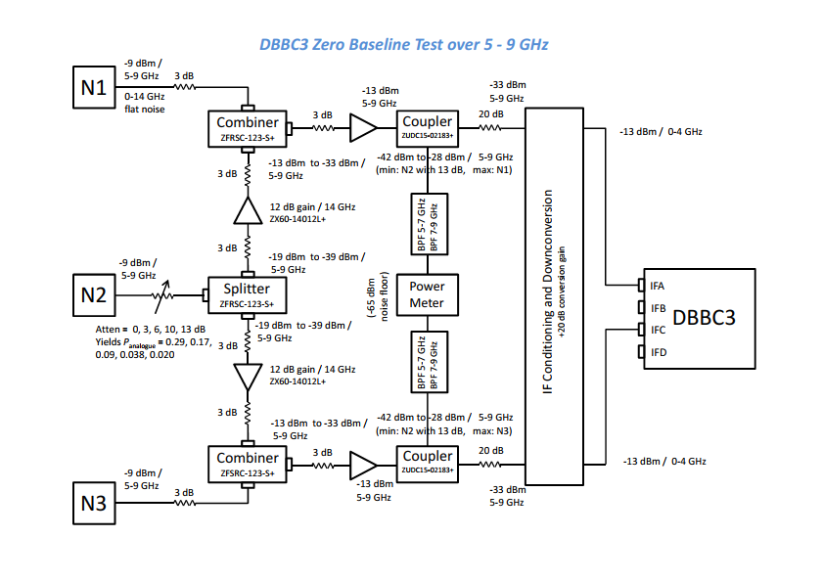

The noise band 5-9 GHz was mixed against a 9048 MHz LO generated from the Valon synthesizer in the GCoMo IFA and IFC to convert to baseband. The baseband noise input to the GCoMo at 0-4 GHz appears in the following figure on the spectrum analyzer. Noise band is quite flat.

|  |  |
| --- | --- |
|  |  |
|  |  |

**Figure:** Spectrum analyzer shows the noise source N1+N2+N3 ***top left***: after 5-9 GHz bandpass filter and before downconversion (horizontal 4500 MHz to 9500 MHz) and ***top right*** after downconversion with LO at 9548 MHz, measured at the GCoMo 0-4 GHz input (horizontal: 0-4000 MHz, vertical 5 dB/div). ***Bottom left*** shows 100 MHz to 10 GHz at the GCoMo 0-4 GHz input for sampling. The strong tone at 9048 MHz is the Valon LO after the doubler coming through the mixer to the IF port. Its level is 0 dBm when zoomed in, compared to the -14 dBm noise power measured 0-4 GHz. The weaker tone at 4524 MHz is the Valon frequency before doubling.

We selected the DBBC3 OCT0-2 digital filter to select the lower part of this band due to the need for rapid setup, even though this is not where the noise bandshape is flattest and has usually produced poorer efficiency measurement than the OCT2-4 band in past measurements.

**Result:**

The measured efficiency with downconversion from 5-9 GHz to 0-2 GHz is overlayed on measurements without downconversion in the following figure.

|  |  |
| --- | --- |
|  |  |

**Figure:** DBBC3 efficiency measured with noise input at 5-9 GHz and downconverted to baseband in the GCoMo and sampled using the OCT0-2 filter. *Left:* ρdigital vs ρanalogue for OCT0-2 band with Van Veck correction applied so efficiency should be the ideal line. *Right:* ρdigital / ρanalogue for the plot at left.

**Table:** DBBC3 efficiency with downconversion

|  |  |  |
| --- | --- | --- |
| ***ρanalogue*** | ***ρdigital*** | ***ratio*** |
| 1.0000 | 0.8290 | 0.8290 |
| 0.6932 | 0.4428 | 0.6388 |
| 0.5344 | 0.3266 | 0.6111 |
| 0.4143 | 0.3067 | 0.7403 |
| 0.3089 | 0.2119 | 0.6860 |
| 0.2256 | 0.1706 | 0.7561 |
| 0.1554 | 0.1019 | 0.6556 |
| 0.1066 | 0.0780 | 0.7316 |
| 0.0694 | 0.0533 | 0.7681 |
| 0.0567 | 0.0401 | 0.7069 |
| 0.0370 | 0.0214 | 0.5781 |
| 0.0236 | 0.0137 | 0.5817 |

**Discussion:**

The efficiency measurement shows considerable scatter and so indicates the measurement is not clean in some way. The best efficiency points match those measured without downconversion, but between the good measurements are poor measurements, being degraded by some cause. Our suspicion falls on the LO tone at 9048 MHz, which has more power than the integrated noise power in the 0‑4 GHz baseband at the GCoMo input and this might badly affect the efficiency measurement. We discovered in this test that the 4 GHz low-pass filter (Mini-Circuits VLF‑3400+) being used after the mixer as a baseband filter to block the LO has poor stop-band attenuation at 9 GHz. When substituted with an excellent Kasemann 0-2 GHz 17 pole low-pass filter that we had on hand the band was cleaned up perfectly, but in the past we have seen lower efficiency measurements with the DBBC3 when presented with 0-2 GHz filtered noise; we need to retrofit with a good 0-4 GHz low-pass filter, but delivery time does not permit the result with that filter to be shown in this test report, so we proceed with efficiency measurements using a Kasemann 2.8 GHz low-pass filter with not quite so good rejection at 9 GHz as a compromise between the 0-2 GHz with excellent rejection but reduced DBBC3 efficiency and the Mini-Circuits VLF-3400+ 4 GHz low-pass filter with poor rejection but good DBBC3 efficiency.

|  |  |
| --- | --- |
|  |  |
|  |  |

**Figure:** Noise source and low-pass filter performance. ***Top left***: Spectrum analyzer display showing the noise source N3 over 0-10 GHz with 10 dB/div. ***Bottom left:*** as for top left but filtered with the Mini-Circuits VLF-3400+ 0‑4 GHz low-pass filter that is used for baseband filtering after downconversion. The filter stop-band rejection is typically 20 dB but at 9.2 GHz near the LO the rejection is nearly 0 dB and so is not suitable for use as a baseband filter and must be replaced. The filter has 7 sections. ***Bottom right:*** as for top left but filtered with the Kasemann 2.8 GHz low-pass filter that was added in series with the Mini-Circuits filter at the DBBC3 0-4 GHz input for the downconversion test.

**ORA #16 (AR):**

***Phase noise on 2048 MHz clock, try different 10 MHz reference***

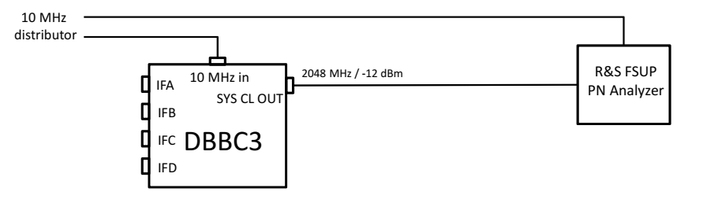

|  |  |
| --- | --- |
|  |  |

**Figure:** Changing 10 MHz reference source from the lab distributor (left) to the Wiltron synthesizer internal reference (right) brings a big reduction in the phase noise at 1 Hz to 30 Hz offset from the 2048 MHz carrier.

Examining the lab 10 MHz reference on the oscilloscope shows periodic amplitude glitches every few milliseconds that should not be there and that the clock synthesizer does not like. Changing reference cleaned up the phase noise, reducing from 87° rms to 1.9° rms at 2048 MHz. The maser at APEX is clean so the 2048 MHz synthesizer is expected to perform within spec.

**ORA #17 (AR):**

***Linearity of IF conditioning module: quantify low-power turn-down***

The report for the 2018 Sep engineering review, in section “Analogue Input Components” subsection “2 Headroom”, showed various measured transfer characteristics of the IF conditioning module and GCoMo during downconversion. This ORA comments on an apparent non-linearity at low power, which was attributed to the noise floor of the spectrum analyzer used in the measurement; the ORA wants to check that this explanation is correct. Here we repeated the measurement using a dual-channel power meter with much lower noise floor.

|  |  |
| --- | --- |
|  |  |

**Figure:** ***Left:*** The system linearity presented in the 2018sep07 engineering review report. The turndown at low power is due to the noise floor of the spectrum analyzer adding to the input signal. ***Right:*** Repeated measurement using power meter and analogue filters to achieve a lower noise floor (-78 dBm instead of -42 dBm noise floor).

We found good linearity using the power meter that extends to much lower input power levels than were covered previously, with no sign of the down-turn.

We found also an unexpectedl gain difference of 10 dB between the two system measurements; time did not allow investigation.

**ORA #32 (SD):**

***Figures or numbers to back up the UTC timestamp and delay jump statements? What are the specs?***

Out of time to summarize result statistics into a table. We have by now conducted hundreds of zero-baseline tests on the DBBC3 vdif data and comparing to R2DBE, and DiFX always finds fringes near zero delay. Thus time-stamping is robustly consistent between DBBC3 and R2DBE. We have never seen an unexpected delay offset. On the rare occasions that fringes were not found or were too weak it was always due to the common noise source N2 having being inadvertently left switched off. In the 20 min recording test (see response to ORA #1 in this document) the amplitude remained stable for 20 min, which would not have happened if delay jumps had occurred.

**ORA #34 (SD):**

***Verify correct transmission at 8Gb/s test: Show DiFX fringe plots with data valid numbers***

Many fringe plots are included in this report showing good validity.

***ORA #39 (SD):***

***Show the Complex Bandpass Phase Flatness***

Examples of bandpass phase response are in the following figures.



**Figure:** 2-4 GHz band DBBC3 IFA vs IFC from 2018nov26 lab zero baseline with 100 % correlated noise input.

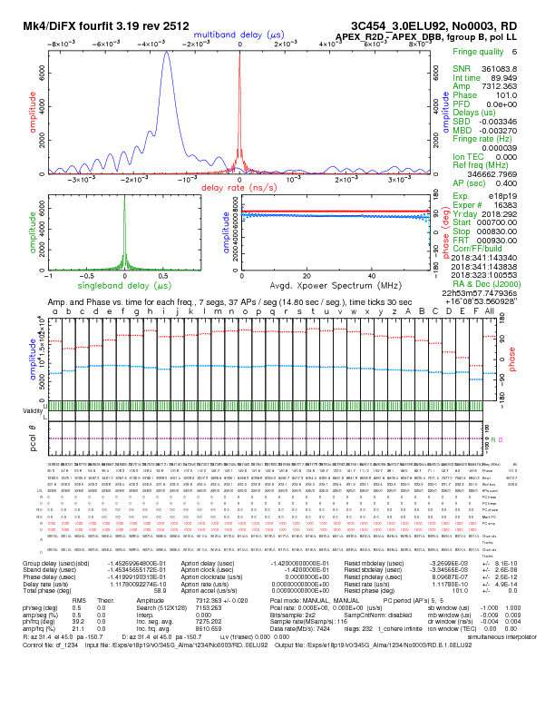

**Figure:** Zero baseline R2DBE-DBBC3 on 2018oct21 EHT 345 GHz fringe test at APEX. The receiver IF was split to both backends giving 100 % correlated noise input.

**Nijmegen suggestion 1:**

***Get agreement between spectrum analyser and DBBC3***

**Issue**

Presently there is a large discrepancy between spectrum analyzer and auto-correlation spectra. Autocorrelation spectra from DBBC3 showed a large peak at the low frequency end which seemed inconsistent with the input power spectrum measured with the spectrum analyzer spectrum. The DBBC3 should be able to reproduce the input spectrum accurately.

|  |  |
| --- | --- |
|  |  |

**Figure:** The figure pair from the Engineering Review that gave a strong impression of inconsistency between the spectrum analyzer (*left)* and the DBBC3 OCT0-2 autocorrelation spectrum *(right)*.

**Result:**

The spectra are found to be consistent when the following steps are taken:

* Set the spectrum analyzer to linear vertical scale
* Measure with spectrum analyzer at the sampler input and not at the GCoMo input since the GCoMo has its own frequency response.
* Square the spectrum analyzer (voltage) scale to give linear power scale for comparison to autocorrelation spectrum, which is on a linear power scale.

These steps resulted in the following spectra:

|  |  |
| --- | --- |
|  |  |
|  |  |

**Figure:** ***Top left:*** spectrum analyzer on sampler input signal, 0-5000 MHz, vertical 0-200 μV linear voltage. ***Bottom left:*** Spectrum analyzer measurements over 0-2000 MHz squared to give linear power scale vertically. ***Bottom right:*** Autocorrelation spectrum from DBBC3 OCT0-2 showing good agreement with the linear power plot bottom left. The autocorrelation spectrum rolls off at the top end due to the OCT0-2 digital FIR filter.

**Nijmegen suggestion 1b:**

***Consider using a flatter noise source from the EHT***

**Result**

We examined the EHT noise source and found it is not flatter than ours. The EHT noise source drops off rapidly above 2 GHz (see figure below), we need noise to 2 GHz, 4 GHz or 9 GHz depending on the test. Our noise source extends to 14 GHz so we continue with it.

|  |  |
| --- | --- |
|  |  |
|  |  |

**Figure:** Noise sources used in the DBBC3 testing (top row and bottom left) compared with the EHT noise source (bottom right), all on the same scale.

|  |  |  |  |
| --- | --- | --- | --- |
| ***Noise source*** | ***Power variation over 0-2 GHz band*** | ***Power variation over 2-4 GHz band*** | ***Power variation over 0-4 GHz band*** |
| MPIfR | 4 dB p-p | 5 dB p-p | 8 dB p-p |
| EHT | 3 dB p-p | 9 dB p-p | 12 dB p-p |

**Nijmegen suggestion 2:**

***Comparison on Sky at 345 GHz Oct 2018 DBB3 parallel with R2DBE***

See ORA #5 above.

**Nijmegen suggestion 3:**

***Fix intermittent known PPS timing bug***

Solved. See ORA #1 above.

**Nijmegen suggestion 4:**

***Evaluate impact of noise passband shape and passband slope***

We made a numerical experiment with Octave to investigate the effect of noise source shape as used in the zero-baseline testing. We generated two partially-correlated random noise time series, shaped them spectrally following the shape of the MPIfR noise source as measured with DBBC3 and m5spec, and applied 2-bit quantization to simulate sampling. This gives realistic noise shape as used in the DBBC3 tests for a numerical study. We formed autocorrelation and cross-correlation spectra and estimated the degree of correlation as in zerocorr or DiFX and compared those to spectra from un-quantized noise.

**Result 1: Quantization Noise Spreads from the Spectral Peak across the Spectrum: Rectangle Test**

In this test we compare autocorrelation spectra from 2-bit quantized data and un-quantized numerically-generated noise time series with a rectangular frequency response.

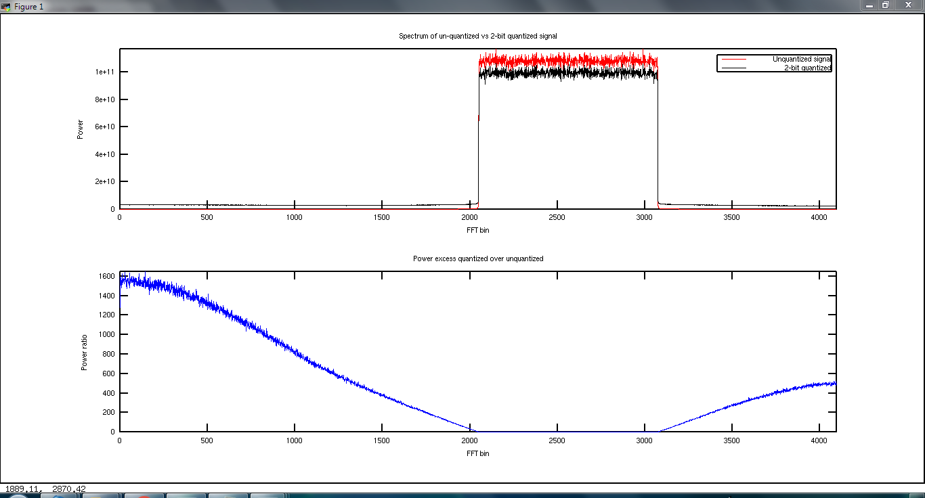

**Figure:** Effect of quantization on frequency distribution of noise power. A random number time series with rectangular frequency distribution was generated and transformed into the frequency domain.with an FFT with or without quantization before the transform. ***Red:*** un-quantized time series. ***Black:*** after 2-bit quantization of the time series. The black (quantized) signal has power outside the passband due to quantization noise spreading across the spectrum.

**Result 2: Quantization noise is uncorrelated:**

We generated two time series with partially correlated noise and rectangular passbands as in the figure above, and applied 2-bit quantization to cause quantization noise spreading in both as above. We cross-multiplied the quantized spectra and found zero cross-power outside the passband. This showed that the quantization noise affects the autocorrelation spectra but not the cross-correlation spectrum outside the passband. Thus when normalizing cross-power spectra by the auto correlation spectra as is done in zerocorr one can expect the spectrum shape to become distorted by the quantization noise, and this would reasonably affect the measured degree of coherence.

**Result 3: Quantization Noise Spreads from the Spectral Peak across the Spectrum: Noise Source Test**

In this test we compare autocorrelation spectra from 2-bit quantized data and un-quantized numerically-generated noise time series that replicate the MPIfR noise source.

|  |  |
| --- | --- |
|  |  |

**Figure:** ***Left:*** Autocorrelation spectra formed using 2-bit quantized (black) or floating point values (red) for one of the noise time series. Horizontal axis spans 0 MHz to 2048 MHz. Away from the peak, the black (2-bit quantized) spectrum lies above the red (un-quantized) spectrum due to quantization noise from the peak. Near the peak around channel 600 the case is reversed with the 2-bit quantized spectrum lying below the un-quantized spectrum due to quantization noise spreading power out from the peak. ***Right:*** Ratio of the black / red spectra (2-bit quantized / un-quantized) spectra in the left panel. This shows 10 % underestimate of the peak autocorrelation amplitude around channel 600, and 10 % over-estimate of the autocorrelation amplitude across much of the remaining spectrum

**Result 4: Quantization Noise Does Not Affect Degree of Correlation Estimate**

In this test we followed the zerocorr processing steps to estimate ρdigital from time series prepared with ρanalog = 0.8 and then 2-bit quantized. Spectra from successive steps are shown below.

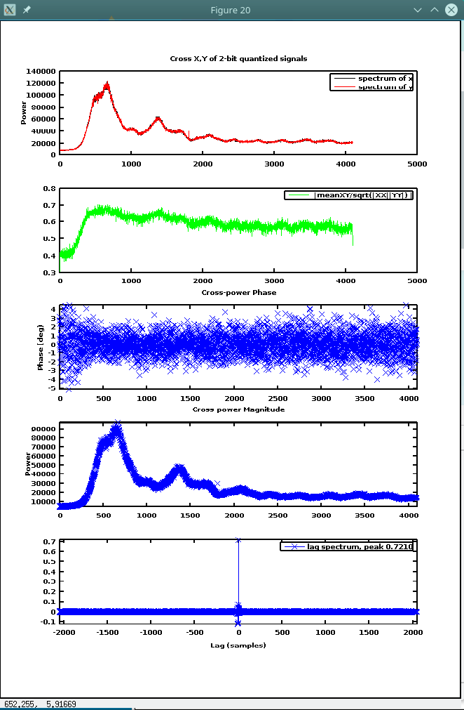

**Figure:** zerocorr-like plots ρanalogue = 0.8 ***Top:*** Stacked FFT spectra of the two time series. ***Second from top:*** Cross-power spectra normalized by the geometric mean of the autocorrelation spectra and stacked. One would expect ρdigital = 0.72 across the spectrum due to 2-bit quantizaion losses, but the spectrum shows lower values due to quantization noise spreading from the peak across the spectrum and increasing the autocorrelations and so lowering the normalized cross-correlation spectrum. ***Third and fourth from top:*** Cross-power phase and amplitude spectra formed between the two random number time series The amplitude drops to zero toward the left band edge showing that the quantization noise in the two streams is uncorrelated. ***Bottom:*** Lag spectrum formed by taking the FFT of the normalized cross-correlation spectrum.

**Result 5: Quantization Noise from Bandshaped Noise Affects DiFX Correlation Estimates**

We discovered by accidental use of DiFX zoom band that one gets higher correlation coefficients when one uses zoomband to restrict the bandwidth to a region that includes the peak of the noise power distribution. The initial discovery was made when we were correlating 2-4 GHz full-band but zoomed into 3-4 GHz and got significantly higher efficiency, 92.7% instead of 85.4 % for ρanalogue = 1.000 for the same vdif files. We explored the effect by reducing the zoom band to 128 MHz and stepping across the 2-4 GHz band in 16 steps, producing the following figure (left panel). The figure also includes the R2DBE for comparison (right panel) measured 2018dec21 in the same way, stepping across the 0-2 GHz band in 16 steps. Note the noise source bandshape is different between left and right panels due to 2-4 GHz in the left panel vs 0-2 GHz in the right panel.

|  |  |
| --- | --- |
|  |  |

**Figure:** Correlation coefficients measured in 128 MHz zoom bands by DiFX, stepping sequentially across the 2 GHz-wide sampled band in 16 steps. ***Left:*** DBBC3 over 2-4 GHz. ***Right:*** R2DBE over 0-2 GHz. The noise power peaks at the left band end and drops off to the right. The input analogue signal was a single noise source split equally to two IF chains of the DBBC3 or R2DBE, so the analogue correlation coefficient is nominally 100 % across the whole band. The dropoff is most likely caused by 2-bit quantization interacting with the noise source bandshape, causing quantization noise to spread away from the noise source peak. Thus one can find system effiiciencies between 98 % and 60 % (or even 25 %) for the DBBC3 depending on the way the vdif files are correlated.

We explored this effect to see whether we could reproduce it numerically. We used the two time series generated in the previous part of this section and correlated in 128 MHz bands and stepped across the band, producing the following figure. As in DiFX we see a dropoff in the correlation coefficient, from 97 % at the peak of the noise source to 75 % at the band edge. The dropoff is not as dramatic as in DiFX but an effect is present.

This shows there is an effect on the correlation coefficient due to the noise source shape interacting with 2 bit sampling causing the spread of quantization noise. This significantly complicates the interpretation of correlation coefficients in the presence of band shape.

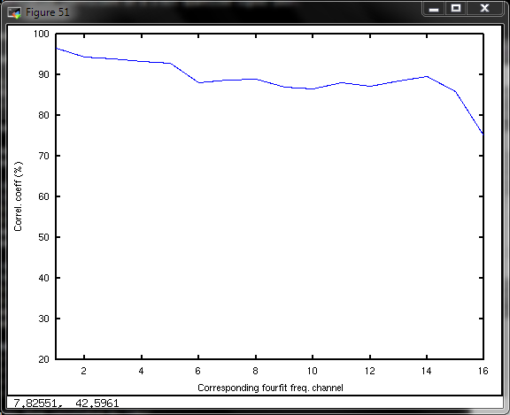

**Figure:** A numerical experiment to reproduce the effect seen with DiFX, for 98 % correlated noise shaped to match the power distribution in the autocorrelation on the real noise source. The cross correlation is formed between the two quantized noise time series, normalizing the cross correlation by the autocorrelations, and averaging in 128 MHz channels as for DiFX. The band slope is an effect of quantization noise spreading combined with the noise source bandshape; the band should be rectangular at near 98 % (Van Vleck correction has not been applied; it’s value would be near unity for such high input correlation coefficient). The drop-off in the last channel is not as extreme as with DiFX on the real noise source although the simulated noise source was shaped in amplitude to match the real one. Most likely the phase response of filters at the edge of the band causes the extra loss in DiFX; we did not shape the phase of the simulated noise source.

**Key Results:**

● Quantization noise distorts the auto-correlation spectra.

● Quantization noise does not affect the cross-power spectrum.

● Normalized cross-correlation is reduced below the 0.88 Van Vleck losses due to distorted auto-correlation spectra used in the normalization.

● ρdigal is recovered with only the Van Vleck loss of 0.88 for Gaussian noise even though the noise source is highly non-Gaussian. This seems inconsistent with the reduced normalized cross-correlation spectra. Resolution lies in differences whether one normalizes cross with autos then stacks, as in panel 2 of the fiture above, or stacks the spectra then normalize. Not fully explored in these tests.

● FFT of the normalized cross spectrum gave 0.72 in the DC term for 0.80, even though the average of the normalized cross spectrum (panel 2 above) was less than 0.72. Cause…

**Octave Script Used in Tests:**

See Appendix A.

**Nijmegen suggestion 5:**

***Fix intermittent known PPS timing bug***

Solved. See ORA #1 above.

***Nijmegen suggestion 6:***

**Compare 0-2 GHz & 2-4 GHz bands, and the different DBBC3 channels.**

**Analogue Combiner Network Improvement**

The combiner network was improved following suggestions passed on by Weintroub et al. to use couplers to measure power from each noise source in turn at the IF input ports of the data acquisition system. The network is shown here.

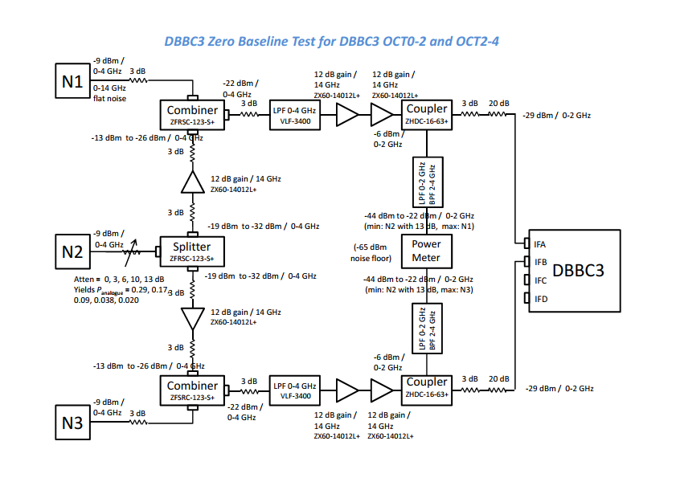

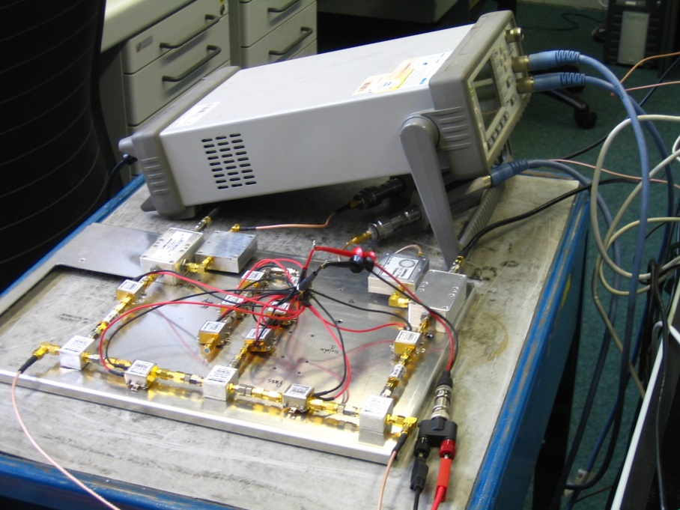

**Data Analysis Improvement: Amplitude Measurement Method Check**

The measurements were long-plagued with inconsistent amplitude estimates between corr2, zerocorr, and DiFX, the last pair being the best and differing at about the 10 % level. This residual 10 % turned out to be DiFX applying amplitude corrections for fringe rotation losses on the baseline but in zero baseline there is no such loss incurred in the data since fringes do not rotate. We could switch off the correction by treating the recordings as two hands of polarization at one station and logged the station LR amplitude, since DiFX knows there is no fringe rotation between polarizations of one station and so does not apply the correction.

We finally achieved good consistency in the cross-check shown here. Agreement was excellent (see the plots below), with systematic difference of 2.6 % (DiFX lower than zerocorr) in the 2-4 GHz band and 1.5 % random difference in the 0-2 GHz band.

|  |  |
| --- | --- |
|  |  |
|  |  |

**Figure:** Check on amplitude consistency between zerocorr and DiFX. Agreement confirms also that zerocorr is applying the Van Vleck correction like DiFX, and so the resulting efficiency estimates should be compared to the ideal case, not 2-bit quantized case.

We made zero-baseline test for OCT0-2 and OCT2-4 bands between DBBC3 IFA - IFC and IFB - IFD channels. Analysis was with zerocorr full-band (gave same result as DiFX full-band), and DiFX zooming into 128 MHz bandwidth at the noise source peak.

|  |  |
| --- | --- |
|  |  |
|  |  |

**Figure:** DBBC3 efficiency based on ρdigital estimate from zerocorr lag spectrum peak amplitudes over full band (*top row*) or DiFX zoom into 128 MHz at the peak of the noise source power spectrum (*bottom row*). *Left panels:* ρdigital vs ρanalogue between four DBBC3 IFs and for OCT0-2 and OCT2-4 bands with Van Veck correction applied so efficiency should be the ideal line. *Right panels:* ρdigital / ρanalogue for the plots at left.

**Discussion:**

These zero-baseline tests are done with the improved analogue combiner network and have much less scatter than previous measurements. The most reliable measurement seems to be the bottom right plot orange curve labelled "IFA vs IFC 2-4 GHz", for which the efficiency is 96.8 % when averaged over all measurements at various ρanalogue values.

The other curves have known residual issues:

IFB vs IFD 2-4 GHz: autocorrelations show an unusual dip in the middle of the band, speculated to be a bad connector in one GCoMo, to be investigated. Probably contributes to the lower efficiency measured in this baseline.

IFA vs IFC 0-2 GHz and IFB vs IFD 0-2 GHz: both show peculiar dropping efficiency to low rho_analogue when using DiFX zoomband to pick 128 MHz around the noise source peak *(bottom row)* but not when correlating full band *(top row)*, so we think this is an artifact of the noise source bandshape interacting with 2-bit quantization and processing.

For the 2-4 GHz band we measure higher efficiency with zoom band than full-band, in this frequency range the noise source is flatter. Clearly there are still effects of noise source bandshape interacting with the 2-bit quantization causing spreading of quantization noise and affecting the efficiency estimates.

|  |  |
| --- | --- |
|  |  |
|  |  |

**Figure:** zerocorr spectra for *(top row):* IFA vs IFC 2-4 GHz, *(bottom row):* IFB vs IFD 2-4 GHz. *Left:* the autocorrelation and cross-correlation spectra. Most of the structure is due to bandshape in the noise source and the FIR filter rolling off the band edges. *Right:* cross correlation normalized by autocorrelation. The bandpass dip in the middle of IFB vs IFD 2-4 GHz is suspiciously like a bad connector in one GCoMo. Higher efficiency is measured in IFA vs IFC than IFB vs IFD.

***Nijmegen suggestion 6 (cont.):***

**Compare R2DBE**

**Analogue Combiner Network Reconfiguration**

The combiner network was reconfigured to filter 0-2 GHz instead of 0-4 GHz and to provide 20 dB higher level (‑7 dBm) to the R2DBE IF inputs, as in the following figure.

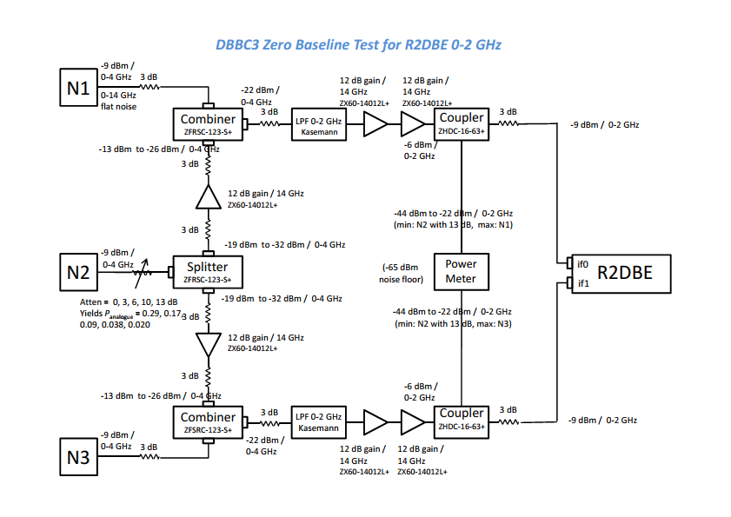Data were acquired and correlated as for the DBBC3, by DiFX treating the two streams as single-station dual polarizations so the amplitude scaling is max 10000 whitney.

|  |  |
| --- | --- |
|  |  |

**Figure:** R2DBE efficiency (marone) compared to the DBBC3 efficiency from the previous section measured with the same methodology: full-band correlation, and Van Vleck correction applied in DiFX or zerocorr.

**Discussion:**

The R2DBE efficiency is a bit better than the DBBC3, yielding average 81.7 % compared to 76.3 % from the figure above right, averaging over the whole range of ρanalogue values tested, summarized in the table below.

|  |  |
| --- | --- |
| ***Data Acquisition System*** | ***Efficiency measured over full band*** |
| R2DBE if0 – if1 | 81.7 % |
| DBBC3 IFB-IFD 2-4 GHz | 76.5 % |
| DBBC3 IFB-IFD 0-2 GHz | 76.0 % |
| DBBC3 IFA-IFC 0-2 GHz | 78.3 % |
| DBBC3 IFA-IFC 2-4 GHz | 75.1 % |

However, these efficiency measurements in both systems are affected by the band shape of the noise source and quantization noise spreading, as seen by he apparent change of efficiency when re-correlating with restricted bandwidth using DiFX zoom band to choose 128 MHz at the peak of the noise source.

***Nijmegen suggestion 6 (cont.):***

**Compare DBBC3 - R2DBE**

**Analogue Combiner Network Reconfiguration**

The combiner network was reconfigured to filter 0-2 GHz to the R2DBE and 0-4 GHz to the DBBC3 and to provide levels appropriate to the two systems (‑9 dBm and -29 dBm), as in the following figure.

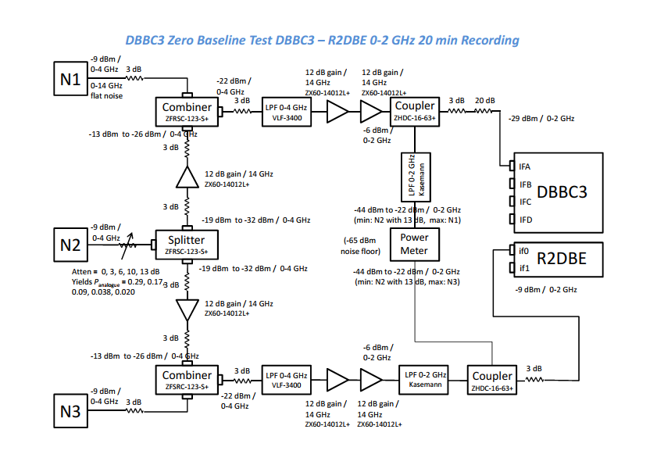

|  |  |
| --- | --- |
|  |  |

**Figure:** R2DBE – DBBC3 zero baseline efficiency (marone) compared to the DBBC3 efficiency from the previous section measured with the same methodology: 128 MHz zoom band and Van Vleck correction applied in DiFX.

**Discussion:**

The R2DBE-DBBC3 baseline efficiency looks rather worse than DBBC3-DBBC3, however much of this effect is likely the analogue filter difference used in this test causing a phase non-linearity across the band. The test should be repeated with the same filters on both systems but time does not permit.



**Figure:** Fringe plot excerpt for the R2DBE – DBBC3 zero baseline test showing considerable phase structure vs frequency that badly affects the measured efficiency. This arose due to different filters used for the two systems.

***Nijmegen suggestion 7:***

**Quad core calibration, reference, acknowledgement lack of spurs shows calibration is adequately executed.**

This is a comment, no action required.

***Nijmegen suggestion 8:***

**Include matching pads between last amplifier and R2DBE**

Done; we moved the 3 dB attenuator from before the main-branch filter to after the last amplifier. See the block schematic in next section (Nimegen suggestion 9).

**Nijmegen suggestion 9:**

***Use identical analogue configuration for DBBC3 and R2DBE***

**Issue**

Keep the analogue signal preparation as similar as possible for R2DBE and DBBC3 comparison. Previously we use 0-4 GHz for DBBC3 and 0-2 GHz for R2DBE. Instead, limit the DBBC3 to 0-2 GHz as for the R2DBE to minimize the configuration changes when comparing systems.

**Setup:**

The analogue combiner was modified as shown below,

1) filter 0-2 GHz low-pass so filter remains same for DBBC3 and R2DBE,

2) add 3 dB pad after coupler before DBBC3 or R2DBE for improved matching,

3) add 20 dB attenuator for level adjustment for DBBC3;

Removing this 20 dB attenuator is the only change needed when changing between DBBC3 and R2DBE.

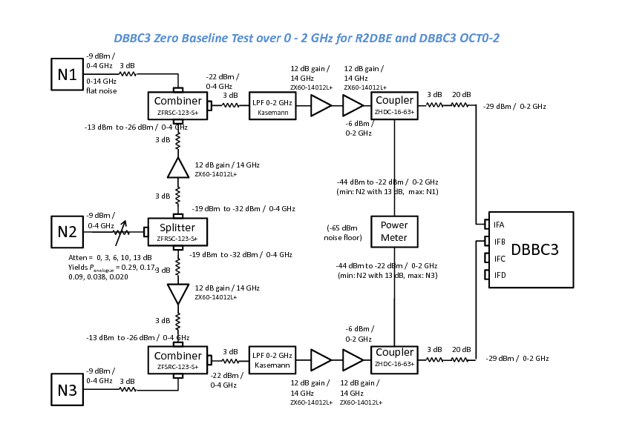

**Figure:** Analogue conditioning configuration for minimal change between R2DBE and DBBC3. Features 0-2 GHz filters and 3 dB attenuator after the coupler. This caused spuriously low efficiency measurements on the DBBC3 and was not used further.

**Result:**

We measured spuriously low efficiency for the DBBC3 with the setup as above. The measurements with 4 GHz vs 2 GHz low-pass filtering is shown in the figure below; efficiencies dropped when the filter was narrowed. The DBBC3 seems happiest with 0-4 GHz noise. Reason is not understood but we proceeded with 0-4 GHz noise input when measuring the DBBC3.

|  |  |
| --- | --- |
|  |  |

**Figure:** *Left:* Output vs input correlation coefficient measured in zero-baseline test between DBBC3 Ifs, for 0-4 GHz baseband noise and low-pass filtered to 0-2 GHz to match R2DBE input hardware. Narrowing the bandwidth causes spuriously lower efficiency. *Right:* Output correlation coefficient divided by the 2 bit theoretical value for 4 GHz- and 2 GHz-low-pass filtered input noise. The efficiency appears spuriously lower for 2 GHz low-pass filtered noise, so subsequent tests continue with 4 GHz LPF.

**Nijmegen suggestion 10:**

***Measure more points in the range ρanalogue = 0 to 0.3***

Done; plots in this document have densified measurements in the correlation coefficient range below 0.3.

**ORA #36 (SD):**

***Fringe Plot Examples***

Typical fringe plots from zero-baseline tests DBBC3-DBBC3 are attached.

**DBBC3 IFA-IFC OCT0-2 2018nov23 ρanalogue = 1.00**

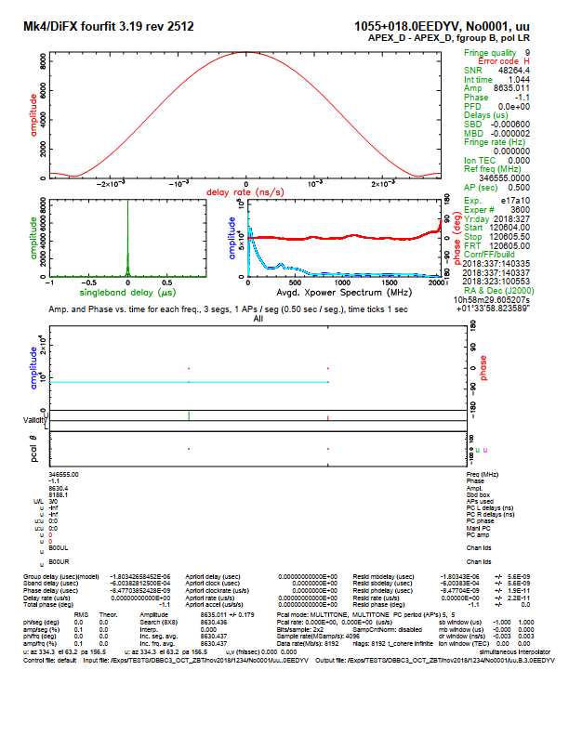

**DBBC3 IFA-IFC OCT0-2 2018nov23 ρanalogue = 0.341**

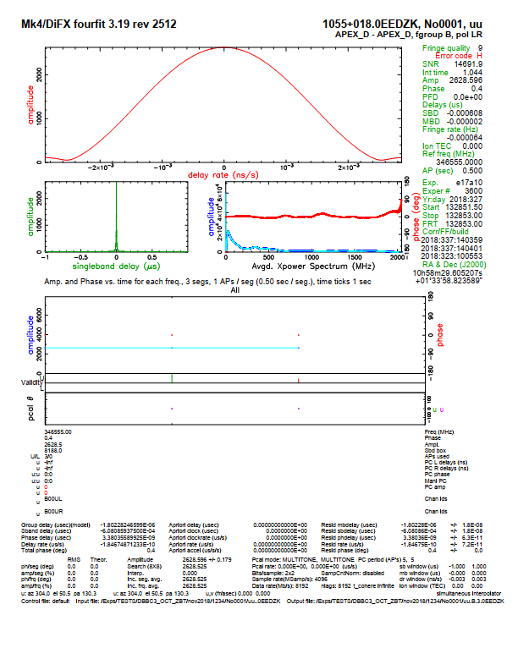

**DBBC3 IFA-IFC OCT0-2 2018nov23 ρanalogue = 0.119**

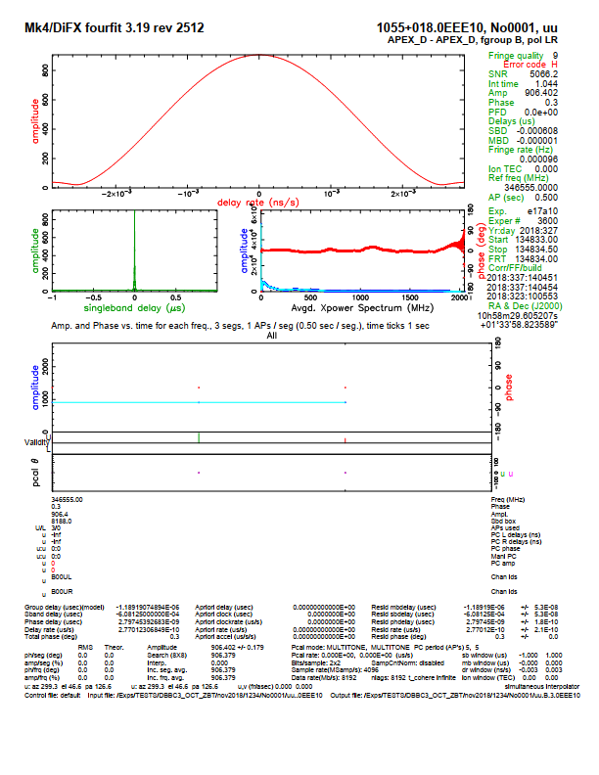

**DBBC3 IFA-IFC OCT0-2 2018nov23 ρanalogue = 0.027**

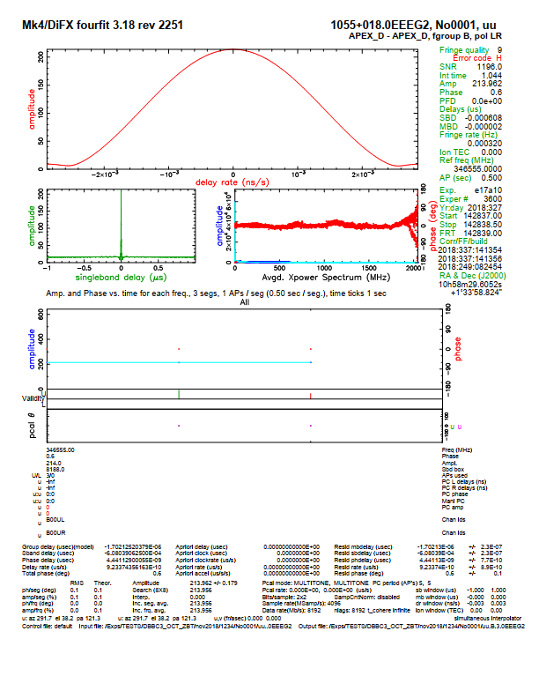

**DBBC3 IFA-IFC OCT2-4 2018nov26 ρanalogue = 1.000**

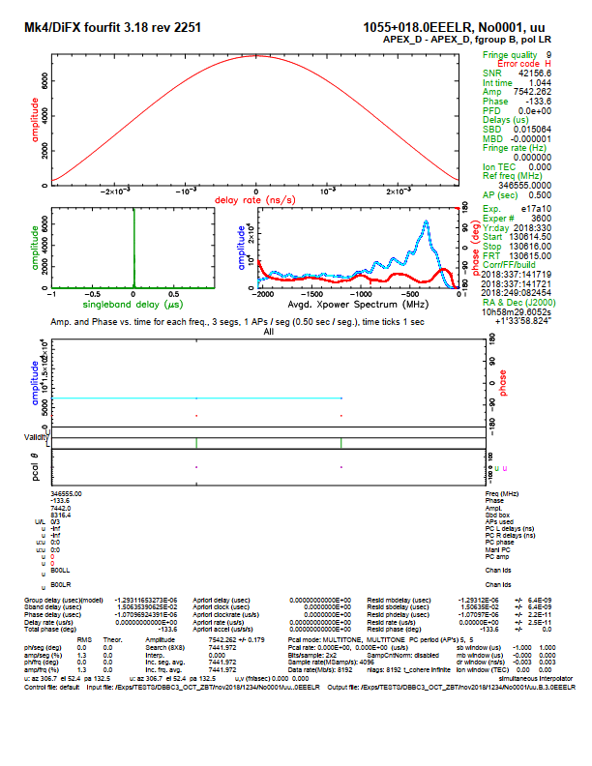

**DBBC3 IFA-IFC OCT2-4 2018nov26 ρanalogue = 0.3385**

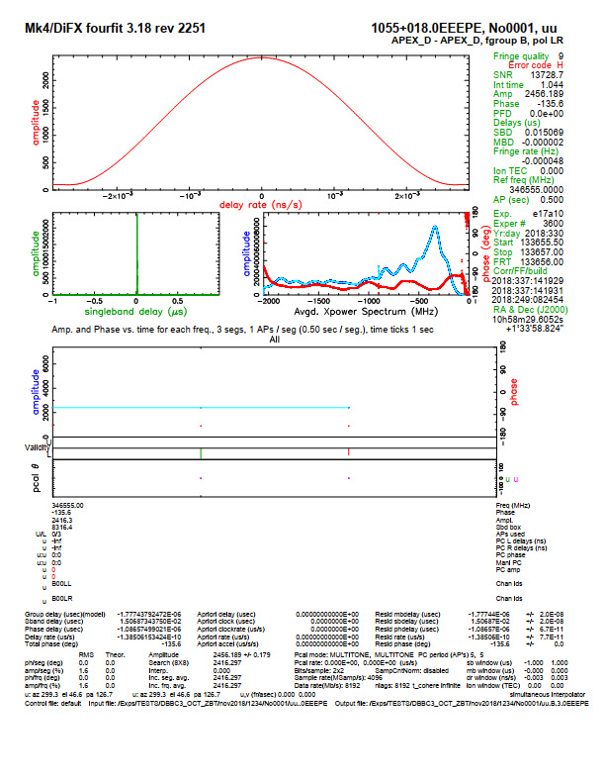

**DBBC3 IFA-IFC OCT2-4 2018nov26 ρanalogue = 0.1162**

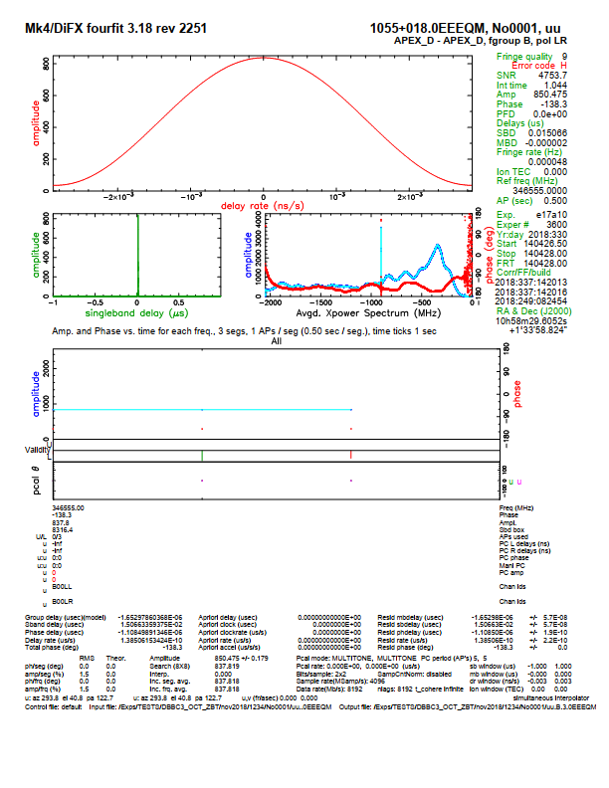

**DBBC3 IFA-IFC OCT2-4 2018nov26 ρanalogue = 0.0267**

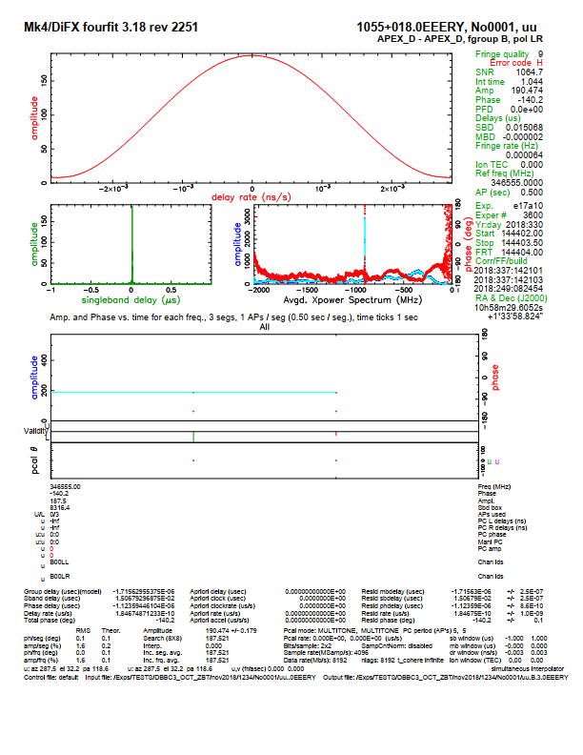

**DBBC3 IFA-IFC OCT2-4 2018nov26 ρanalogue = 0.000**

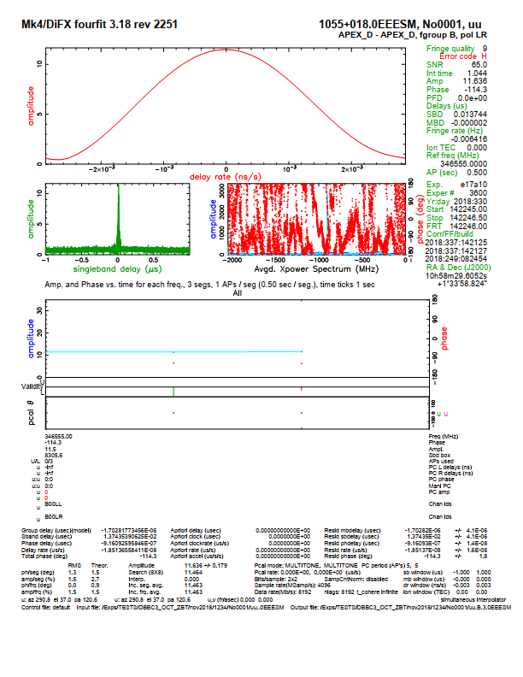

**DBBC3 IFA-IFC OCT0-2 2018nov23 ρanalogue = 0.247**

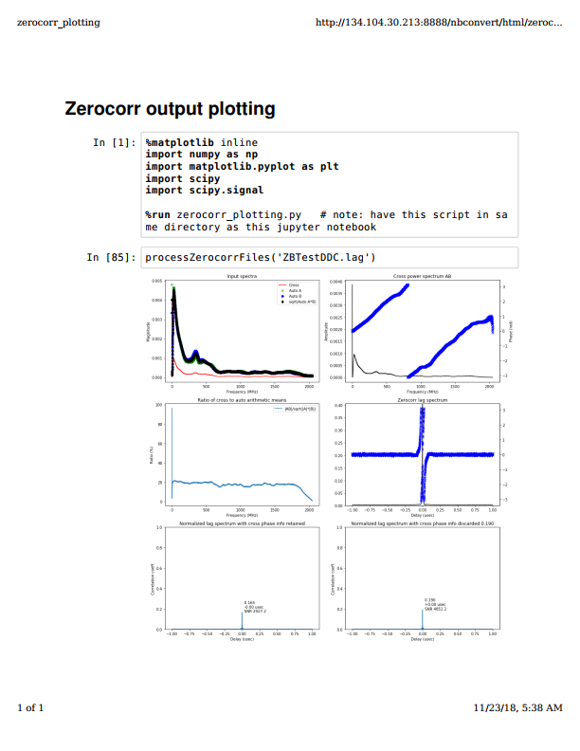

**DBBC3 IFA-IFC OCT2-4 2018nov26 ρanalogue = 0.252**



**DBBC3 IFB-IFD OCT0-2 2018dec03 ρanalogue = 0.244**

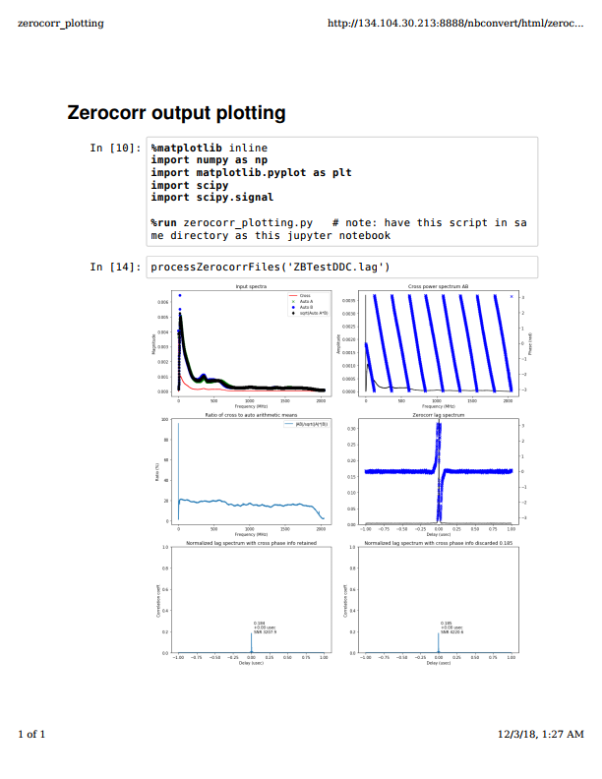

**DBBC3 IFB-IFD OCT2-4 2018dec03 ρanalogue = 0.247**

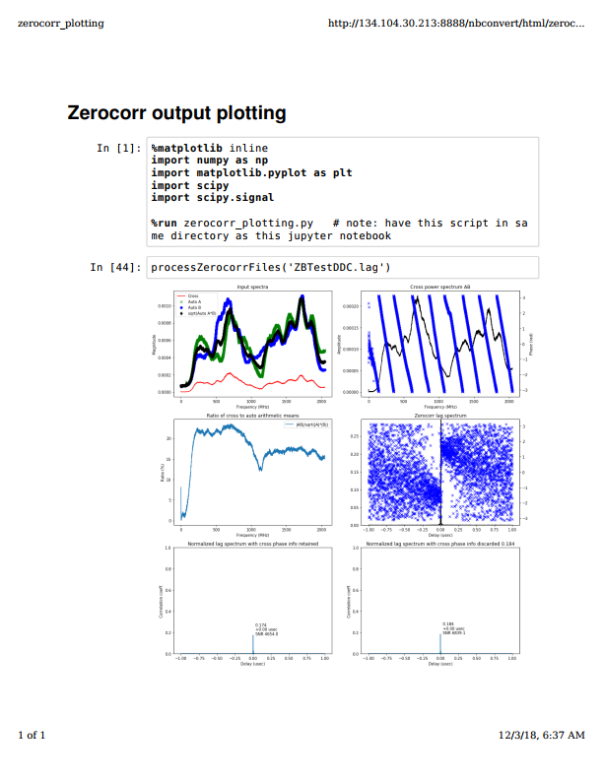

**R2DBE if0-if1 2018dec11 ρanalogue = 0.249**

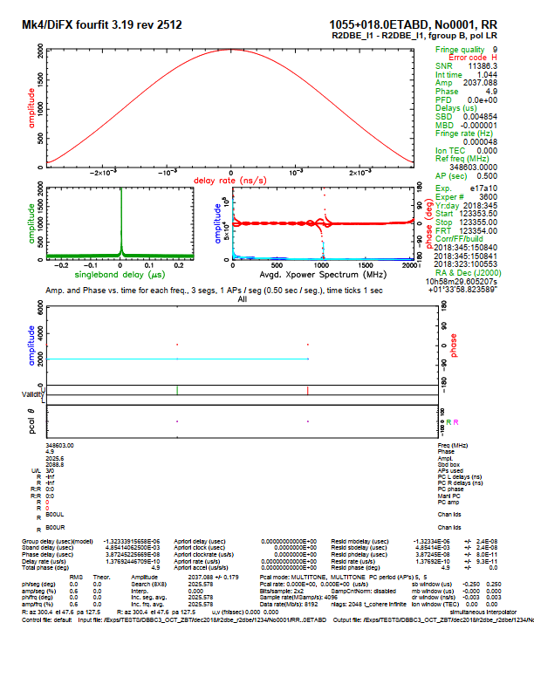

**R2DBE if0-if1 2018dec11 ρanalogue = 0.033**

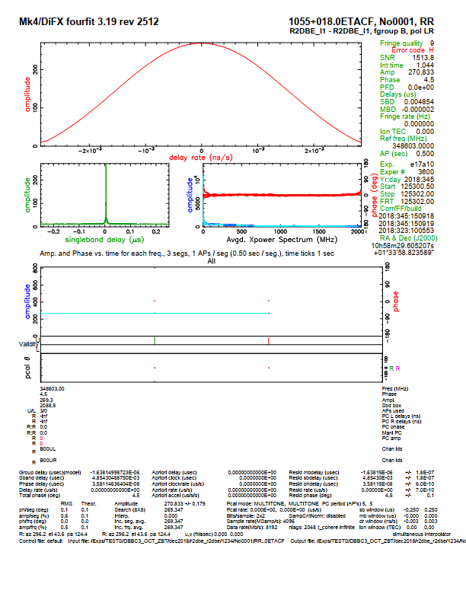

**DBBC3 IFC OCT0-2 - R2DBE if0 2018dec10 ρanalogue = 0.226**

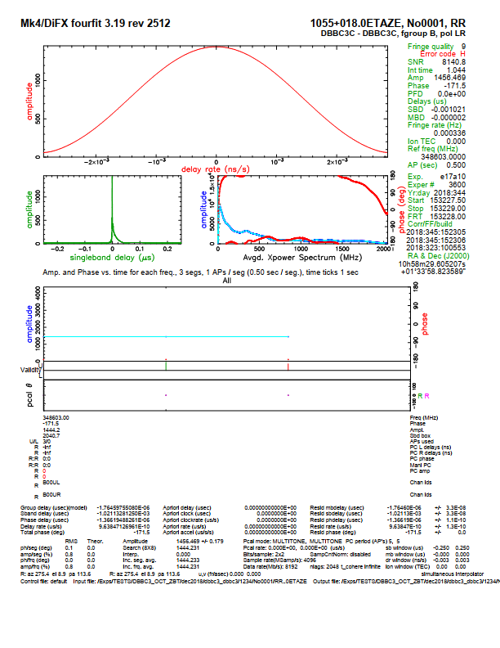

**DBBC3 IFC OCT0-2 - R2DBE if0 2018dec10 ρanalogue = 0.050**

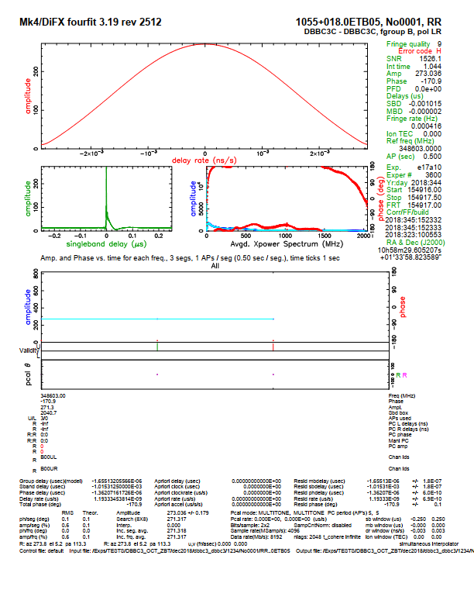

**DBBC3 IFA – IFC OCT2-4 downconverted from 5-7 GHz 2018dec13 ρanalogue = 1.000**

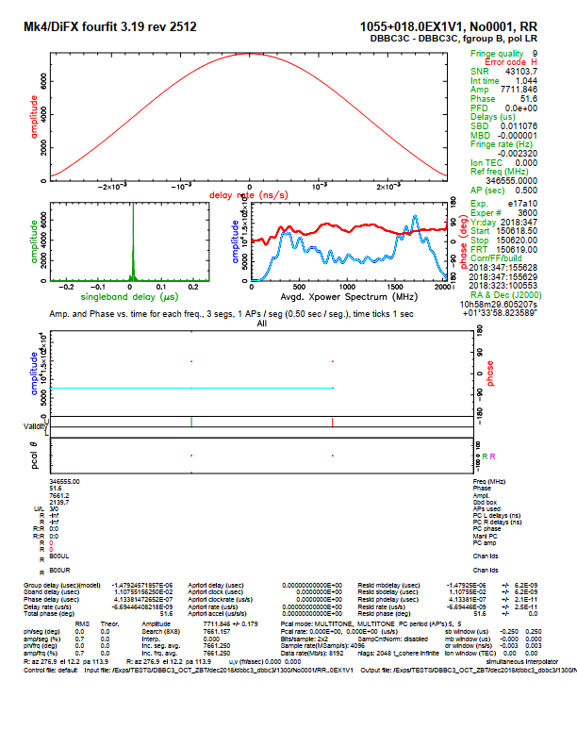

**Appendix A:**

***Code for Nijmegen Suggestion 4:***

***Evaluate impact of noise passband shape and passband slope***

%%

%% Test the impact of bandpass shape (or noise source spectral shape)

%% on the correlation coefficient of a 2-bit quantized signal pair.

%%

function bandshapeImpact()

graphics_toolkit("gnuplot");

rho = 0.98; % desired correl coefficient, pre-quantization

Lfft = 8192;

N = Lfft * 128;

% bandshape = [] : vector of weights on frequency bins, ideally half length of Lfft

% (in reshapeSpectrum() the weights are contatenated (original ; left-right flipped)

% bandshape = [ones(1,Lfft/4), zeros(1,Lfft/4), ones(1,Lfft/4), zeros(1,Lfft/4)]; % two windows

bandshape = [zeros(1,Lfft/4), zeros(1,Lfft/4), ones(1,Lfft/4), zeros(1,Lfft/4)]; % single window

bandshapex = bandshape; bandshapey = bandshape;

%

%% Actual shape, determined with Python m5spec.py (voltage spectrum)

%% 2-4 GHz

% $ m5spec.py /data/TESTS/dbbc3_nov18/vdif/ZB_DBBC3_2-4_261118_100pc_a.vdif VDIF_8192-8192-1-2 100 8192

% $ m5spec.py /data/TESTS/dbbc3_nov18/vdif/ZB_DBBC3_2-4_261118_100pc_b.vdif VDIF_8192-8192-1-2 100 8192

%bandshapex = loadM5spec('ZB_DBBC3_2-4_261118_100pc_a.8192pt.m5spec', is_power=false);

%bandshapey = loadM5spec('ZB_DBBC3_2-4_261118_100pc_b.8192pt.m5spec', is_power=false);

%

%% Actual shape, determined with Python m5spec.py (voltage spectrum)

%% 0-2 GHz

% $ m5spec.py /data/TESTS/dbbc3_nov18/vdif/ZB_DBBC3_231118_100pc_a.vdif VDIF_8192-8192-1-2 100 8192

% $ m5spec.py /data/TESTS/dbbc3_nov18/vdif/ZB_DBBC3_231118_100pc_b.vdif VDIF_8192-8192-1-2 100 8192

%bandshapex = loadM5spec('ZB_DBBC3_231118_100pc_a.8192pt.m5spec', is_power=false);

%bandshapey = loadM5spec('ZB_DBBC3_231118_100pc_b.8192pt.m5spec', is_power=false);

% Make random signals, shaped

x = randn(N,1);

y = randn(N,1);

x = reshapeSpectrum(x,bandshapex);

y = reshapeSpectrum(y,bandshapey);

% Make them correlated by 'rho'

% Note: do this before quantizing, since afterwards the voltages would not be -3.3,-1.0,1.0,3.3

[xx,yy] = mixSignals(x,y,rho);

% Time-domain integer sample delay?

% yy = shift(yy, -2);

% Quantize to 2-bit

fprintf(1, 'Quantizing signal x(t)...\n');

xq = quantize2bitVLBI(xx);

fprintf(1, 'Quantizing signal y(t)...\n');

yq = quantize2bitVLBI(yy);

% Correlate

c0 = corr(xx(:),yy(:));

c0qhat = vanVleck(c0);

c0q = corr(xq(:),yq(:));

fprintf(1, 'Correlation coeff. time-domain:\n');

fprintf(1, ' goal parameter for mixSignals() rho=%.6f\n', rho);

fprintf(1, ' corr(x,y) before 2-bit quantization=%.6f, expected %.6f post van Vleck\n', c0, c0qhat);

fprintf(1, ' corr(x,y) after 2-bit quantization=%.6f\n', c0q);

fprintf(1, ' ratio=%.6f\n', c0q/c0);

fprintf(1, ' rho_q/rho_q_hat ratio=%.6f\n', c0q/c0qhat);

fprintf(1, '\n');

% Plot: quantization noise

showSpectrumRatio(xx,xq, Lfft, 1, 'Spectrum of un-quantized vs 2-bit quantized signal');

# h = gcf(); print (h, "test.pdf", "-dpdflatexstandalone"); # not working on 'frontend'

% showSpectrum(x, Lfft, 10, 'Original x');

% showSpectrum(xx, Lfft, 11, 'Post-Cholesky x');

showSpectrum(xq, Lfft, 12, 'Signal X: Cholesky-correlated, 2-bit');

showSpectrum(yq, Lfft, 12, 'Signal Y: Cholesky-correlated, 2-bit');

% Plot: cross-power

showCrossSpectrum(xq,yq, Lfft, 20, 'Cross X,Y of 2-bit quantized signals');

% showCrossSpectrum(xx,xq, Lfft, 21, 'Cross X[float], X[2-bit]');

end

% Van Vleck curve

function c0q = vanVleck(c0)

% 1-bit case : https://arxiv.org/pdf/1608.04367.pdf Figure 1

% c0q = (2/pi) * asin(c0);

% 2-bit case: https://agupubs.onlinelibrary.wiley.com/doi/pdf/10.1029/98RS02202 Eq 5 (too long)

c0q = c0 * 0.88;

end

% Load a m5spec file, for use as template bandpass shape

% File format pf .m5spec: col1 = freq (Hz), col2 = amplitude

%

% Note: Python 'm5spec.py' produces voltages

% C-code 'm5spec' produces powers

function w = loadM5spec(filename, is_power=false)

dd = dlmread(filename);

w = dd(:,2);

w = w ./ sum(w);

% figure(4),plot(dd(:,1),dd(:,2)),title(filename);

w = w(1:(numel(w)-1)); % discard Nyquist

if is_power,

w = sqrt(w);

end

end

% Alter a signal pair to have a given correlation coefficient

function [xx,yy] = mixSignals(x,y,rho)

X = [x(:), y(:)];

rho_current = (corr(X))(2,1);

Ldecorr = chol([1, -rho_current; -rho_current 1]);

L = chol([1, rho; rho, 1]);

X = (X*Ldecorr)*L;

xx = X(:,1);

yy = X(:,2);

end

% Quantize a signal to 2-bit -corresponding levels

function xq = quantize2bitVLBI(x)

fprintf(1, 'Original signal : mean=%+.3f std=%.3f\n', mean(x), std(x));

% Emulate 8-bit ADC

if 0,

s = std(x);

adc_offset = (s/4)*rand(1,1);

x = x + adc_offset;

x = floor(16 * x./s);

x (x <= -127) = -127;

x (x >= +128) = +128;

figure(8), clf, hist(x,255), title('Histogram for 8-bit quantized signal')

fprintf(1, 'Quantizing to 8-bit prior to 2-bit, adc offset=%.3f\n', adc_offset);

end

% Threshold, corresponding fill-in voltage post-decode 2bit->float

% see e.g. Section 5.2 of https://arxiv.org/pdf/1210.7271.pdf (derivation is in some much older papers though)

v0 = 0.9815;

n = 3.3359;

% Boundaries, see http://iaaras.ru/media/library/kchap4.pdf PDF page 41, Table 1 "Clipping criteria"

x = x - mean(x);

xn = x ./ std(x);

xq = xn;

xq(xn < -v0) = -n;

xq(and(-v0 <= xn, xn < 0)) = -1.0;

xq(and( 0 <= xn, xn < v0)) = +1.0;

xq(xn >= v0) = +n;

%% 4-level histogram ; histc() histogram edges(k) <= x < edges(k+1)

eps = 0.5; bin_edges = [-n-eps,-1.0-eps,0,+1.0+eps,+n+eps];

H = histc(xq,bin_edges);

H = 100 * H(1:4) ./ sum(H(1:4));

Hstr = num2str(H', '%.2f%% ');

fprintf(1, 'Quantized signal : mean=%+.3f std=%.3f : 4-level distribution %s\n', mean(xq), std(xq), Hstr);

fprintf(1, '\n');

end

% Reshape a noise signal

function s = reshapeSpectrum(x,channelamplitudes)

w = channelamplitudes(:);

w = [w; flipud(w)];

L = numel(w);

N = floor(numel(x)/L);

xsub = x(1:(N*L));

for ii=1:N,

istart = 1 + (ii-1)*L;

istop = istart + L-1;

s = xsub(istart:istop);

s = real(ifft( fft(s) .* w ));

xsub(istart:istop) = s;

end

s = xsub;

end

% Spectrum of signal

function showSpectrum(x,Lfft,fignr=1,figname='')

Nfft = floor(numel(x)/Lfft);

xsub = x(1:(Nfft*Lfft));

S = zeros(Lfft,1);

for ii=1:Nfft,

istart = 1 + (ii-1)*Lfft;

istop = istart + Lfft-1;

s = xsub(istart:istop);

S = S + abs(fft(s));

end

S = S(1:floor(numel(S)/2 + 1)) ./ Nfft;

figure(fignr), clf;

plot(S);

xlabel('FFT bin');

ylabel('Amplitude');

title(figname);

end

% Spectrum of signal

function showCrossSpectrum(x,y, Lfft, fignr=1,figname='')

Nfft = floor(numel(x)/Lfft);

xsub = x(1:(Nfft*Lfft));

ysub = y(1:(Nfft*Lfft));

XX = zeros(Lfft,1);

YY = zeros(Lfft,1);

XY = zeros(Lfft,1);

F = zeros(Lfft,1);

for ii=1:Nfft,

istart = 1 + (ii-1)*Lfft;

istop = istart + Lfft-1;

fx = fft( xsub(istart:istop) );

fy = fft( ysub(istart:istop) );

fxx = fx.*conj(fx);

fyy = fy.*conj(fy);

fxy = fx.*conj(fy);

XX = XX + fxx;

YY = YY + fyy;

XY = XY + fxy;

%% Normalized cross-power: normalize then average?

%% --> c = 75

F = F + fxy ./ sqrt(real(fxx) .* real(fyy));

end

%% Normalized cross-power: average separately, then normalize?

%% --> c = 0.69 (factor ~100 lower than above)

Falt = XY ./ sqrt(real(XX) .* real(YY)); %% avg'd first, then normalized

% Time-domain, lag spectrum

xx0 = (ifft(XX))(1);

yy0 = (ifft(YY))(1);

xy_td = fftshift(ifft(XY)) ./ sqrt(xx0 * yy0);

max_amp = max(real(xy_td)); % expected to be the same as 'rho'/0.88 at the very start of this file

lags = (1:numel(xy_td)) - floor(numel(xy_td)/2);

fprintf(1, 'Fourier-based cross-corr : %.6f amp peak in lag spec of %s\n', max_amp, figname);

% Freq-domain,

M_xx = mean(XX);

M_yy = mean(YY);

M_xy = mean(XY);

R = real(M_xy) / sqrt(M_xx * M_yy);

fprintf(1, 'Freq.domain. mean power, correl coeff from ratio of across-band means of <XY>,<XX>,<YY> = %.6f\n', R);

% correl.coeff. when including cumulatively more bandwidth

R_cum = real(cumsum(XY) ./ sqrt(cumsum(XX) .* cumsum(YY)));

figure(50), clf;

plot(R_cum,'x')

% correl.coeff. when splitting the spectra into N_zooms regions

% compareable with fourfit

N_zooms = 32; L_segment = numel(XX)/N_zooms;

M_xx = mean(reshape(XX, [L_segment,N_zooms]), 1);

M_yy = mean(reshape(YY, [L_segment,N_zooms]), 1);

M_xy = mean(reshape(XY, [L_segment,N_zooms]), 1);

R = real(M_xy) ./ sqrt(M_xx .* M_yy);

% R = R ./ 0.88; %% van Vleck

figure(51), clf;

hold on;

plot(100 * R(1:(N_zooms/2)));

axis tight;

xlabel('Corresponding fourfit freq. channel');

ylabel('Correl. coeff (%)')

ylim([20,100]);

% rather than power --> coeffs, try ifft()

tmp_td = [];

for nn=1:N_zooms,

i0 = 1 + (nn-1)*L_segment;

tmp = F(i0:(i0+L_segment-1));

td = real(fftshift(ifft(tmp,2*L_segment)));

td = max(td) * sqrt(L_segment);

tmp_td(end+1) = td;

end

size(tmp_td)

tmp_td

plot(100 * tmp_td(1:(N_zooms/2)), 'rx-');

% incorrect results with:

% F_td = real(fftshift(ifft(F)));

% F_td = F_td / sqrt(numel(F));

% fprintf(1, 'Correl coeff from inv FFT of normalized cross-power spectrum = %.6f\n', max(F_td));

% Keep non-redundant side of spectra

XX = XX(1:floor(numel(XX)/2 + 1)) ./ Nfft;

YY = YY(1:floor(numel(YY)/2 + 1)) ./ Nfft;

XY = XY(1:floor(numel(XY)/2 + 1)) ./ Nfft;

F = F(1:floor(numel(F)/2 + 1)) ./ Nfft;

Falt = Falt(1:floor(numel(Falt)/2 + 1)) ./ Nfft;

XY_ph = angle(XY)*(180/pi);

XY_mag = abs(XY);

figure(fignr), clf;

subplot(5,1,1), hold on,

plot(XX,'k');

plot(YY,'r');

legend('spectrum of x', 'spectrum of y');

ylabel('Power')

title(figname);

subplot(5,1,2), hold on,

sc = max(abs(F)) / max(abs(Falt));

plot(abs(F),'g');

plot(abs(Falt) * sc,'r');

legend('Mean of normalized XYs', 'Normalized avg of mean XY');

axis tight;

subplot(5,1,3), plot(XY_ph, 'x'), title('Cross-power Phase'), ylabel('Phase (deg)'); axis tight; ylim([-180,180]);

subplot(5,1,4), plot(XY_mag, 'x'), title('Cross-power Magnitude'), ylabel('Power'); axis tight;

subplot(5,1,5), plot(lags,real(xy_td), 'x-');

legend(sprintf('lag spectrum, peak %.4f', max_amp)),

xlabel('Lag (samples)'),

axis tight;

end

%

function showSpectrumRatio(x,y, Lfft,fignr=1,figname='')

Nfft = floor(numel(x)/Lfft);

x = (x - mean(x)) ./ std(x);

y = (y - mean(y)) ./ std(y);

xsub = x(1:(Nfft*Lfft));

ysub = y(1:(Nfft*Lfft));

X = zeros(Lfft,1);

Y = zeros(Lfft,1);

R2 = zeros(Lfft,1);

for ii=1:Nfft,

istart = 1 + (ii-1)*Lfft;

istop = istart + Lfft-1;

xs = xsub(istart:istop);

ys = ysub(istart:istop);

X = X + abs(fft(xs));

Y = Y + abs(fft(ys));

R2 = R2 + abs(fft(ys)).^2 ./ abs(fft(xs)).^2;

end

% power spec and non-reduntant part of spectrum only

X = X.^2;

Y = Y.^2;

X = X(1:Lfft/2);

Y = Y(1:Lfft/2);

R2 = R2(1:Lfft/2);

% ratio or comparison

R = Y ./ X;

figure(fignr), clf;

subplot(2,1,1), hold on, plot(X,'r-'), plot(Y,'k-');

axis tight;

xlabel('FFT bin');

ylabel('Power');

legend('Unquantized signal', '2-bit quantized');

title(figname);

subplot(2,1,2), plot(R);

axis tight;

xlabel('FFT bin');

ylabel('Power ratio');

title('Power excess quantized over unquantized');

end

**Appendix B:**

***VLBA Project Book Excerpt with System Specifications:***

